Applying TIM Manager Approval
- SHRA Non-Exempt employees must approve their timecards each biweekly pay period.
Deadline for employee approval is set by your department.
- After the TIM Manager has reviewed and edited employee timecards so they are ready for payroll and employee approval has been applied, he or she approves the timecard. Employees cannot edit or approve their timecards after TIM Manager approval has been applied.
- TIM Manager approval at the end of the pay period lets the TIM Administrator know the timecards are ready for processing.
- A TIM Manager can edit data even after approving a timecard.
- The TIM Manager approval deadline is set by your department.

Steps for Approving Timecards: Managers
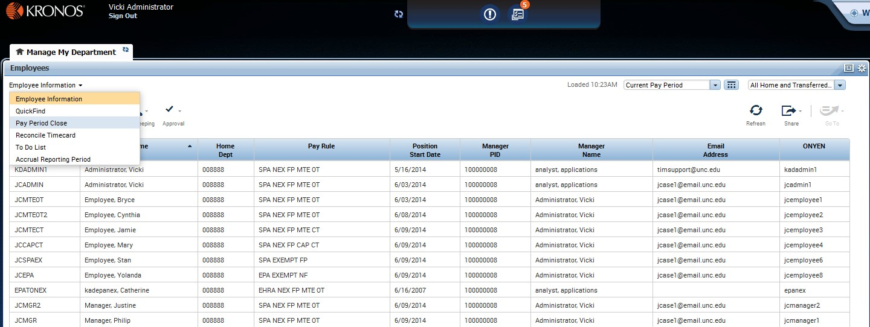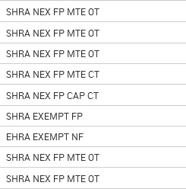

Log in to TIM and select Pay Period Close
on the Genie Selector.

Check to see if there are any employees who have not approved their timecard. A check mark in the Employee Approval column means the employee has approved.

A TIM Manager can approve an employee’s timecard even if the employee has not. If you approve a timecard that the employee has not approved, print a time detail report for that pay period, have the employee sign it, and place it in his or her file.
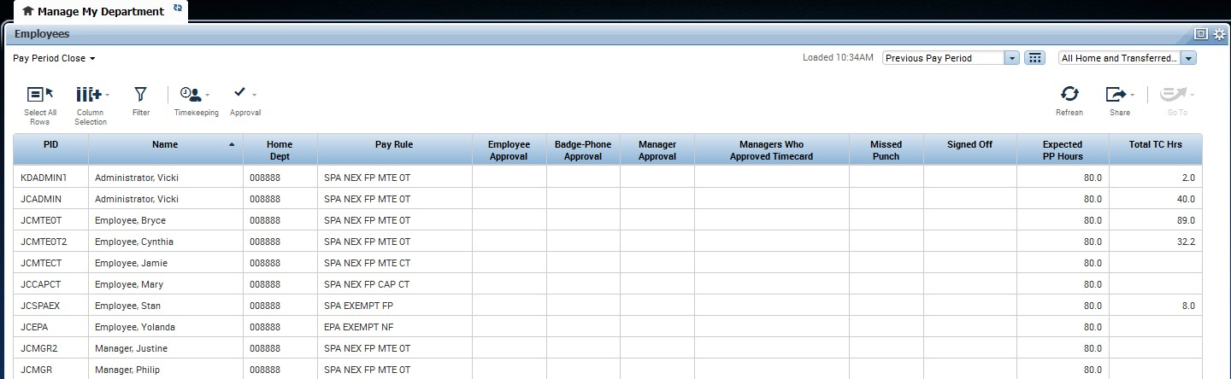 Check to see if there are any employees who have a missed punch. A check mark in the Missed Punch column indicates that an employee has a missed punch. This is also indicated if a number appears in an orange circle in the top right of the Exceptions Alert in TIM.

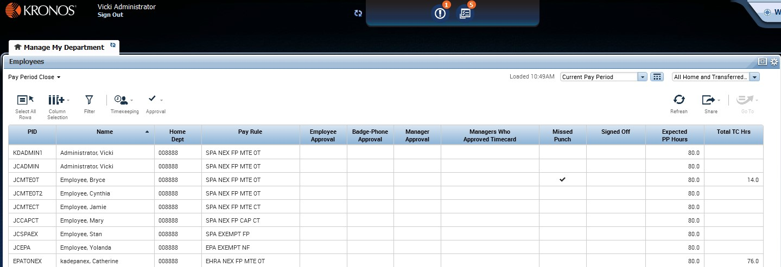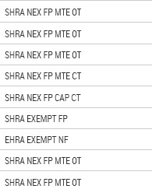

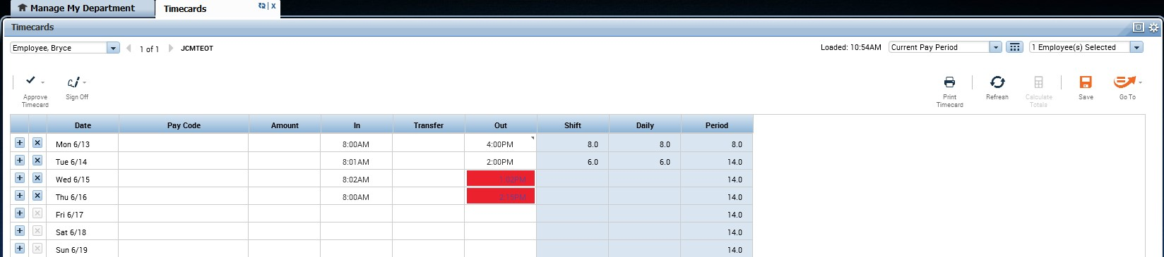
If there are missed punches, double click the row assigned to t
he employee with a missed
punch to display his or her timecard.

If needed, contact the employee to find out the time out that is missing. Enter the time of
the missed punch in each of the cells that appear red on the screen. Then click Save.

Click the X in the top right of the employee’s timecards tab header to return to the Pay Period Close genie.
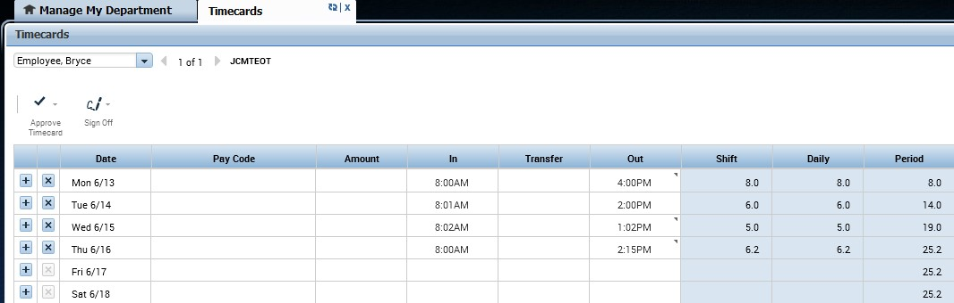

Click the refresh icon in the top right of the Manage My Department tab header.

The missed punch check mark and the orange circle in the top right corner of the Exceptions Alert should disappear if the employee timecard was edited successfully.
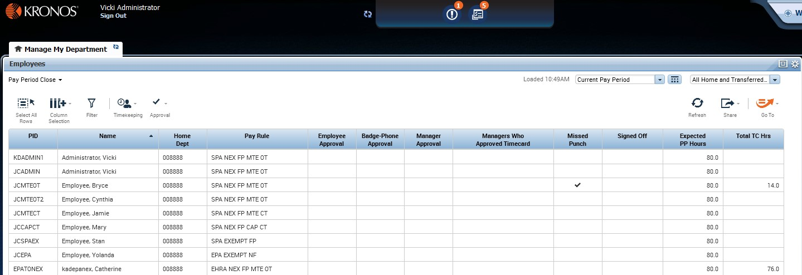
Before Clicking Refresh

After Clicking Refresh
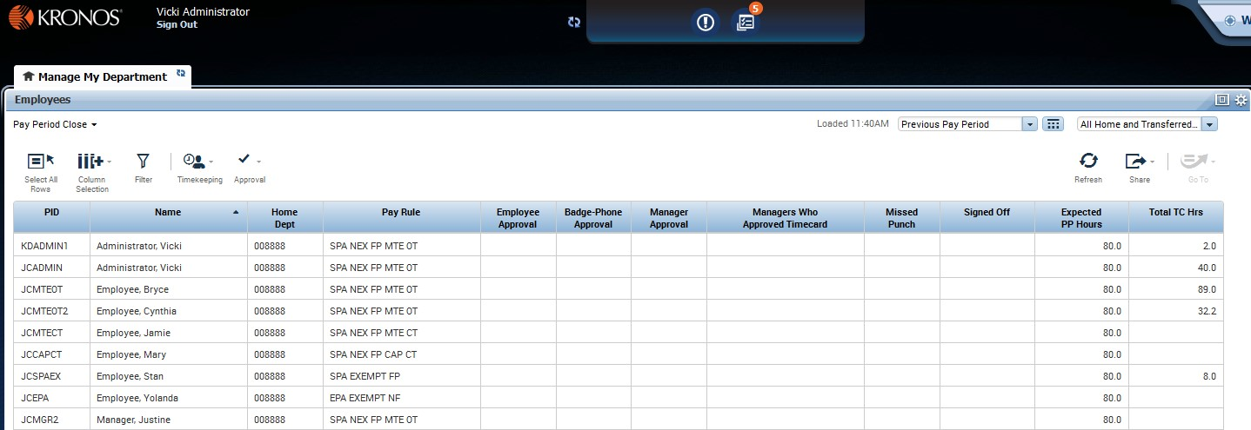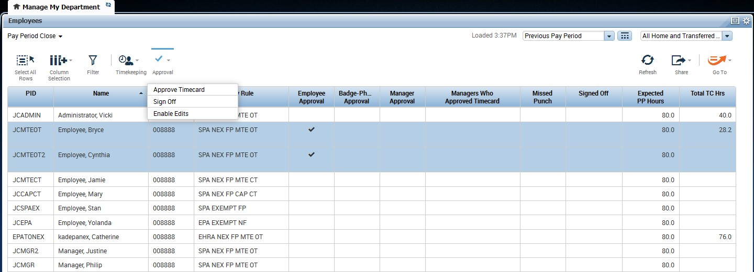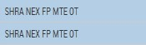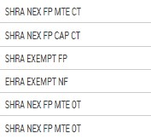

After you have reviewed and updated the timecard if needed, approve those employee
timecards by selecting them

in the list and clicking Approval then Approve Timecard.

❖ Before your department’s manager approval deadline, be sure to review and approve timecards.

