- Please visit http://cae.med.unc.edu

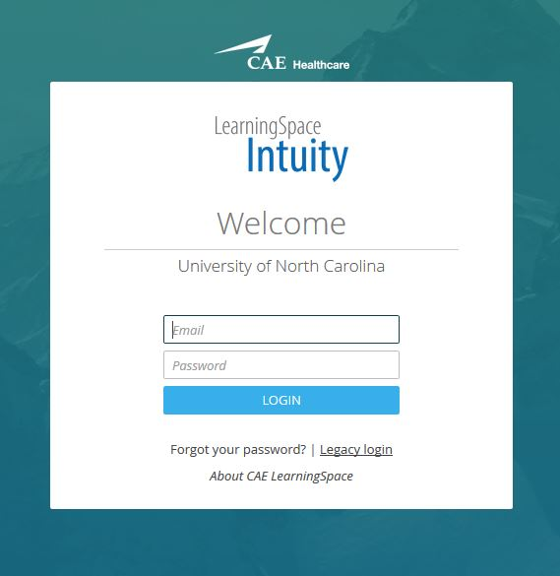

Select Legacy Login and choose your role.

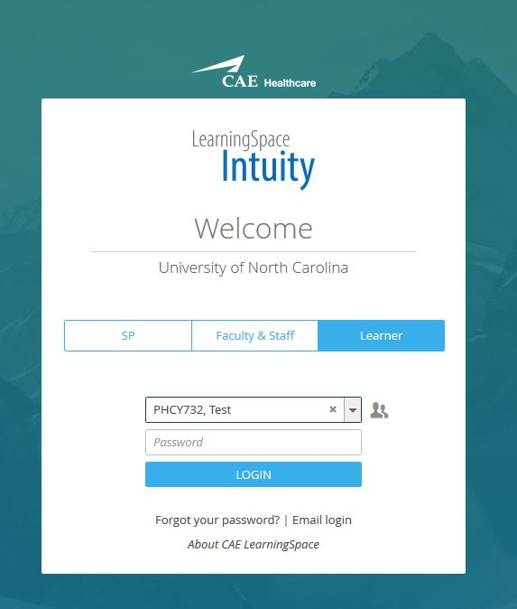

Search field by your name or team name. Log in via your ONYEN password, or team password given to you. Contact your administrator if you have trouble logging in.

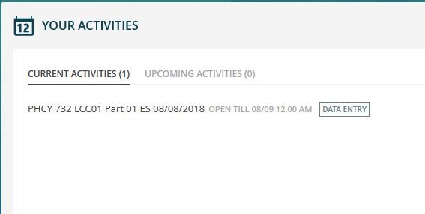
If you are given an assignment, you will be able to select DATA ENTRY option.
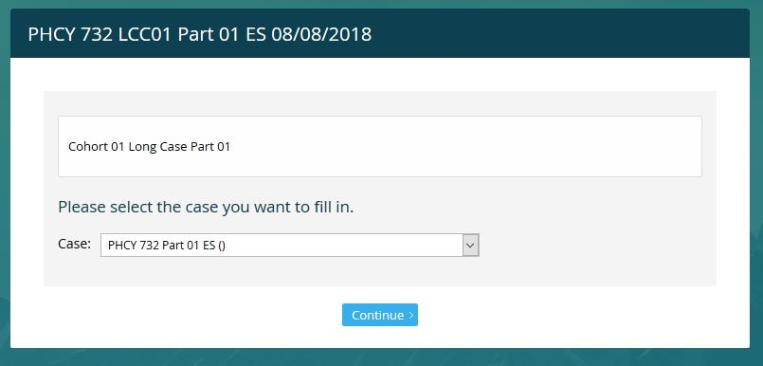
Select the case you are submitting and you will be able to submit your assignment.

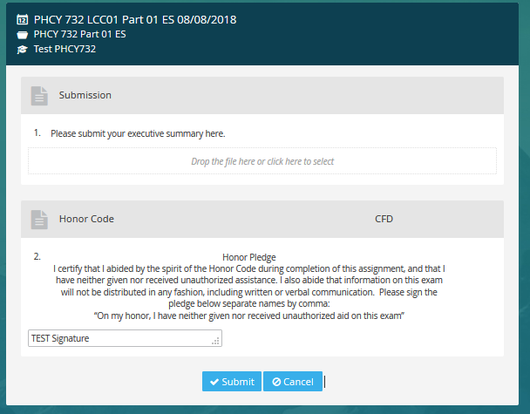
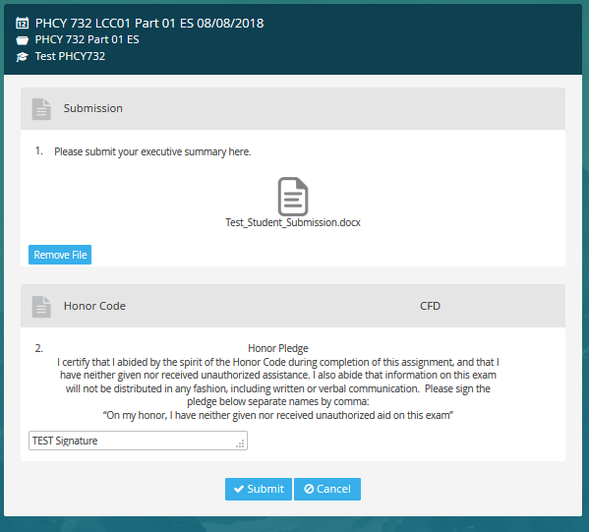

Once you’ve uploaded your assignment, enter your name(s) under the honor code and select Submit to save. You will see a confirmation of submission.

