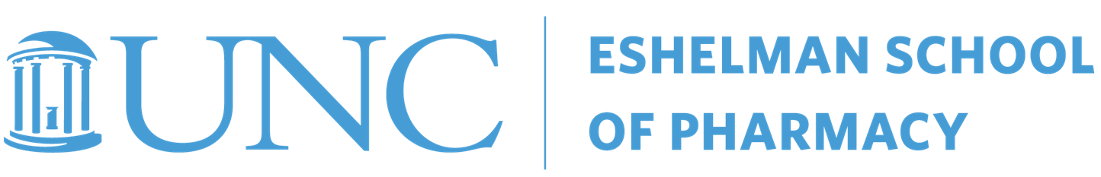
“Excellence in the Time of COVID and Beyond”
Pharmaceutical Sciences Research & Graduate Education Retreat
January 6 (1-4pm); January 7 (9am-12); January 8 (9am-12), 2021
Location: Zoom
FACULTY, POSTDOCTORAL FELLOWS, GRADUATE STUDENTS, & RESEARCH STAFF
January 6 (Wednesday)
1:00pm Welcome Organizing Committee
1:05-1:30 Keynote Address: Global Health - Challenges & Opportunities in a Rapidly Changing World
Dan Hartman, MD, Director, Integrated Development, Global Health, Gates Foundation
1:30-2:00 Case Study: Navigating Conflicts in Research & Innovation Breakout Group Discussions
2:00-3:00 Research Presentations Graduate Students & Postdoctoral Fellows
3:00-4:00 Professional Development: Mentoring
Students: Identifying Effective Mentors and Making the Most of their Guidance Dave McDonald
Faculty: Building Effective Mentoring Relationships Susan Pusek

January 7 (Thursday)
9:00-10:00am Research Presentations Graduate Students & Postdoctoral Fellows
9:30-10:30 Pop-up Sessions (EII; COI/COC/EPAP; TIBBS; PharmAlliance; eRA Commons; ORCID; Collaborators)
10:00-10:30 Masters Program Updates Kathryn Morbitzer; Merrie Mosedale
10:30-11:00 Case Study: Navigating Conflicts in Research & Innovation Breakout Group Discussions
11am-noon Professional Development: Zoom Interviewing Skills for Interviewers and Interviewees
Faculty: Best Practices for Interviewers Jacqui McLaughlin
Recruitment Weekend and Multiple Mini-Interviews (MMI) Olivia Hammill
Students: Alumni Panel Discussion: Drs. Ferslew, Ghibellini, Harner and Keppler

January 8 (Friday)
9:00-10:00am “Big Idea” Grants & Assembling the Teams ID3@UNC & READDI: Drs. Moorman, Pearce, Willson
T32 Clinical Pharmacology: Drs. Watkins & Gonzalez; Open-AD Drug Discovery: Drs. Frye & Willson
10:00-10:30 Case Study: Navigating Conflicts in Research & Innovation Breakout Group Discussions
10:30-11:00 Pop Up Sessions (EII; COI/COC/EPAP; PharmAlliance; eRA Commons; ORCID; Collaborators)
10:30-11:00 Graduate Education Discussion Mike Jarstfer
11:00-11:30 2021 Research & Grad Ed Vision - UNC Eshelman School of Pharmacy Dean Kashuba
11:30-11:55 2020 Trainee Awards & Presentation Winners Mike Jarstfer
11:55-noon Closing Remarks Kim Brouwer

